1. Run the command in terminal as below,

*pip install gunicorn whitenoise*

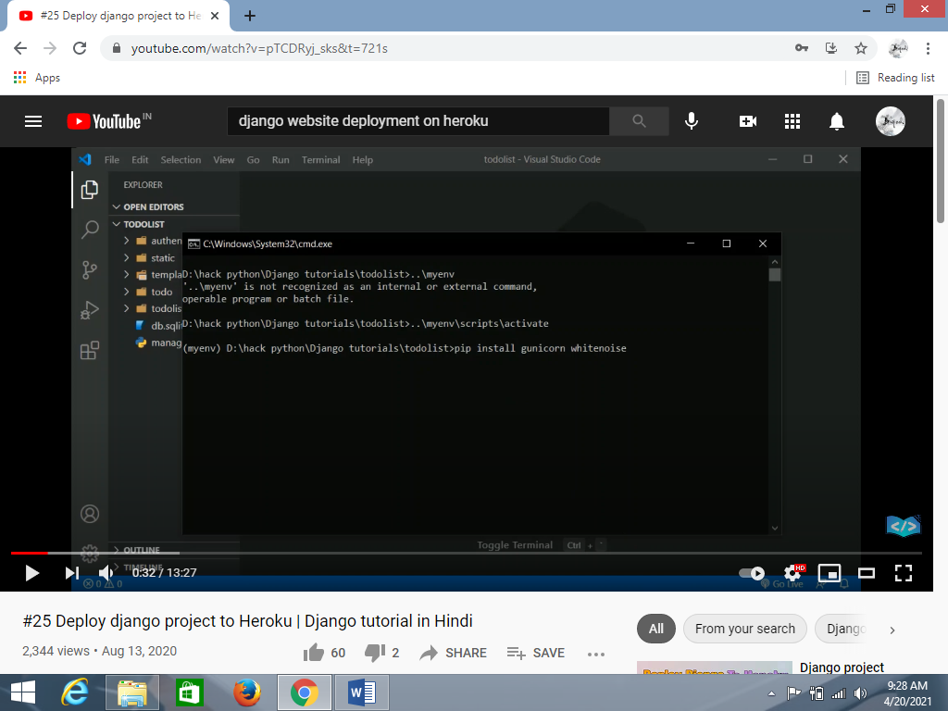

1. For creating requirements.txt file run the command in terminal as below,

*pip freeze > requirements.txt*

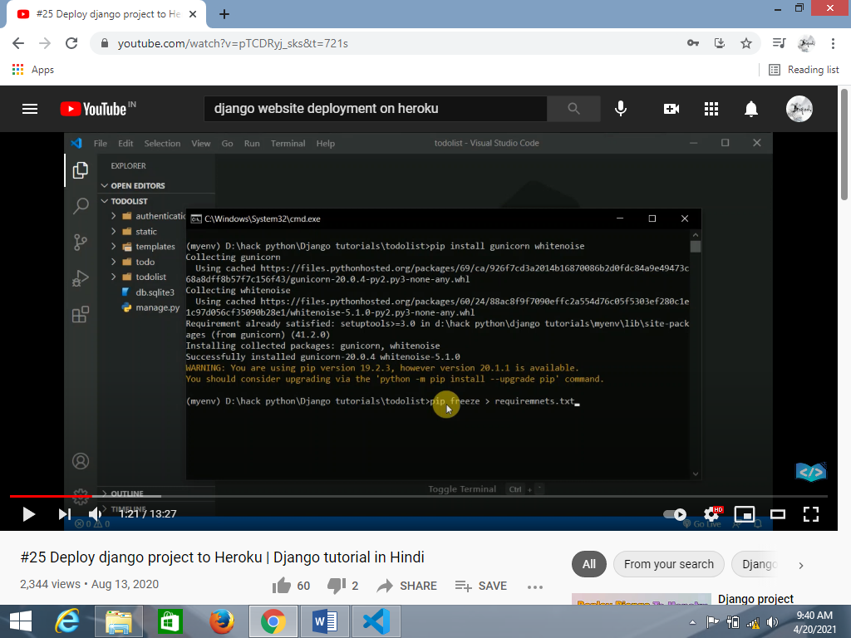

1. For create Procfile manually in main project directory as below,

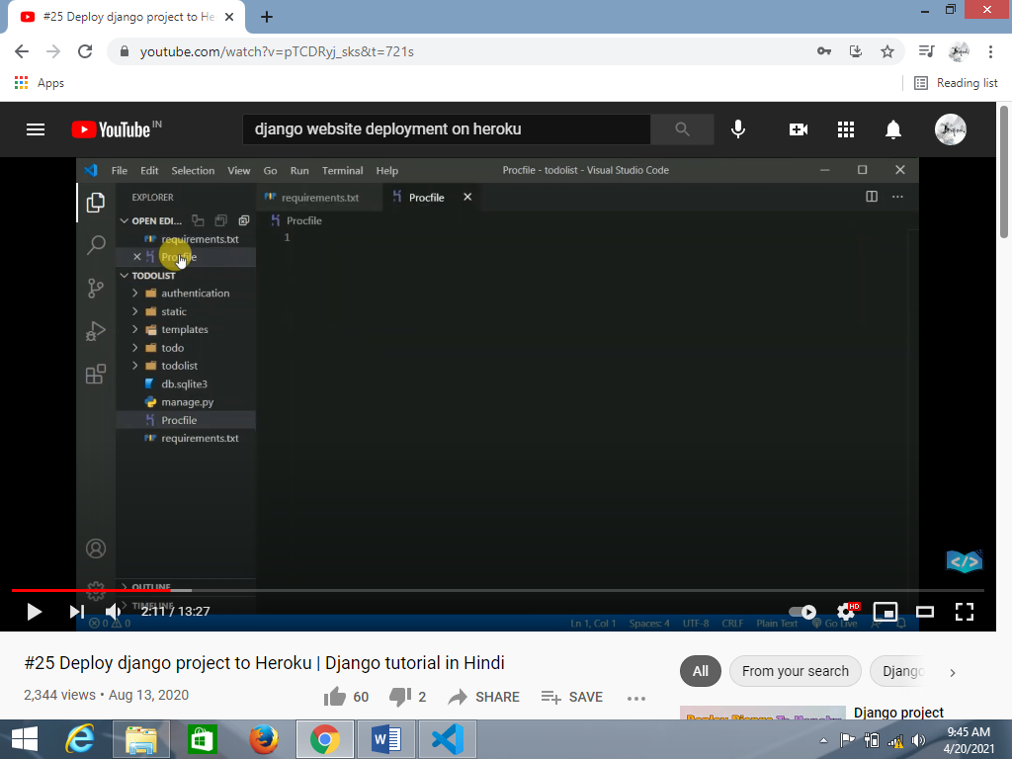

1. Write below code in Procfile & save,

*web: gunicorn gettingstarted.wsgi –log-file –* Replace the code ‘gettingstarted’ by ‘projectname’

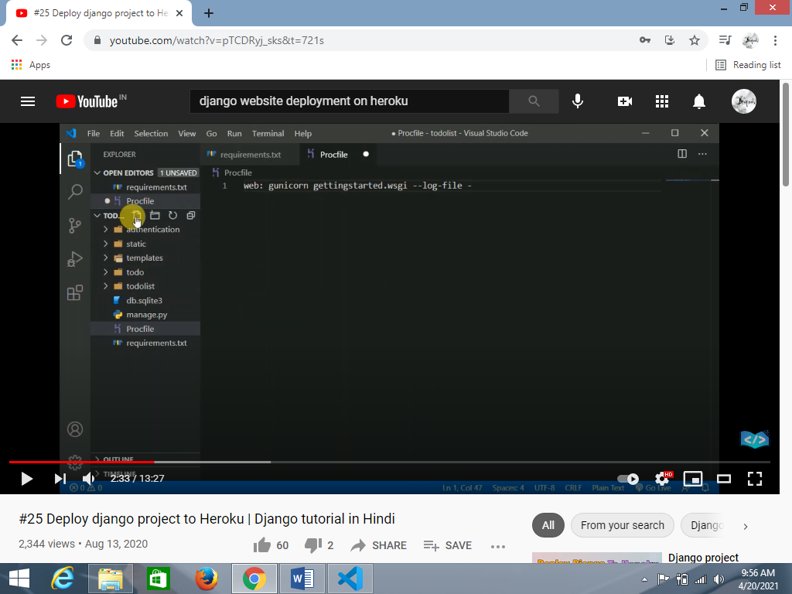

Replace the code ‘gettingstarted’ by ‘projectname’

1. Install Heroku CLI
2. Create account on Heroku
3. Install Git
4. Check version of installed Heroku by *heroku –version*
5. Copy the provided link in heroku account in setting as below,

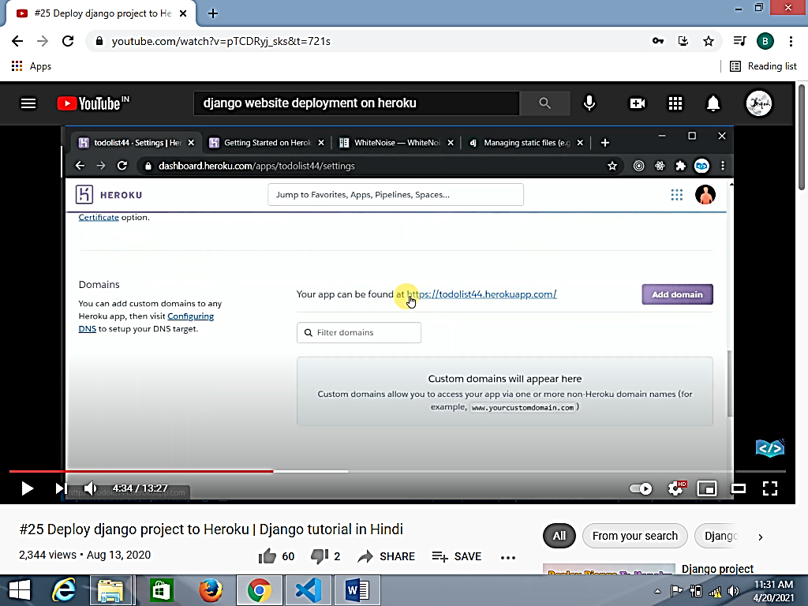

1. Past the copied link in app setting allowed Host [‘ ’], also allow, ‘localhost’

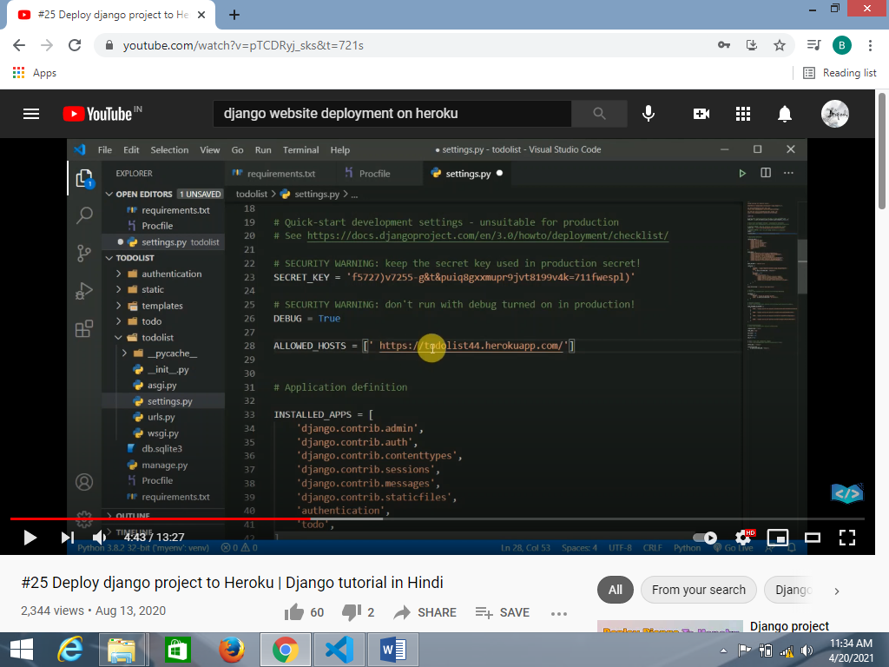

1. DEUG = False for deploy
2. visit whitenoise website for below codes,

'whitenoise.middleware.WhiteNoiseMiddleware',

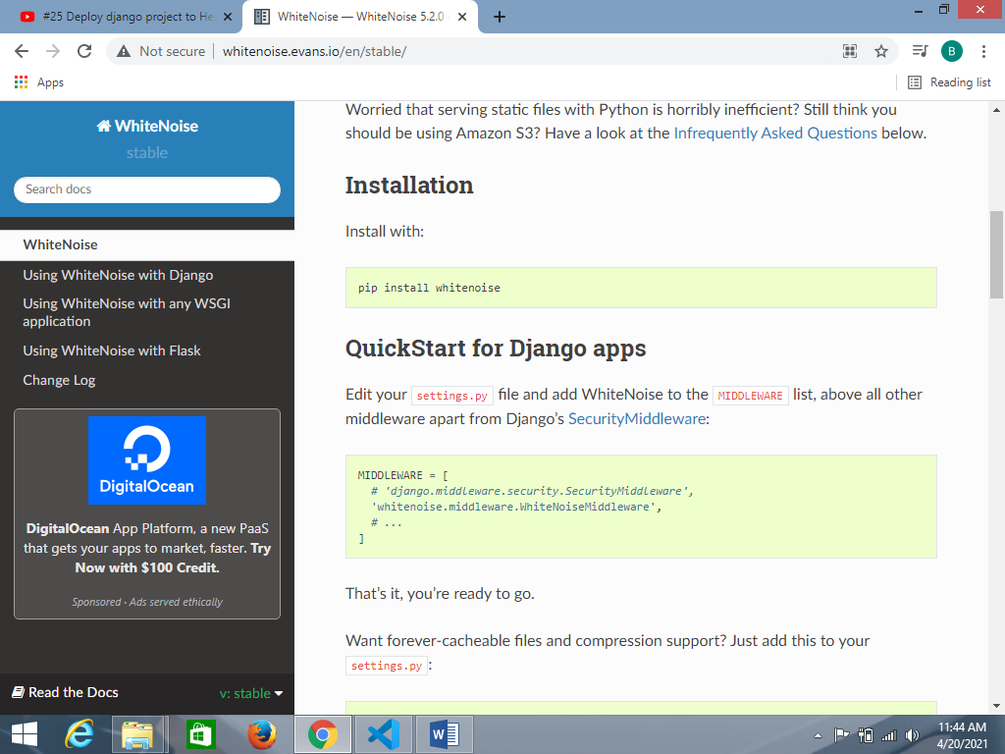

Past in setting MIDWARE

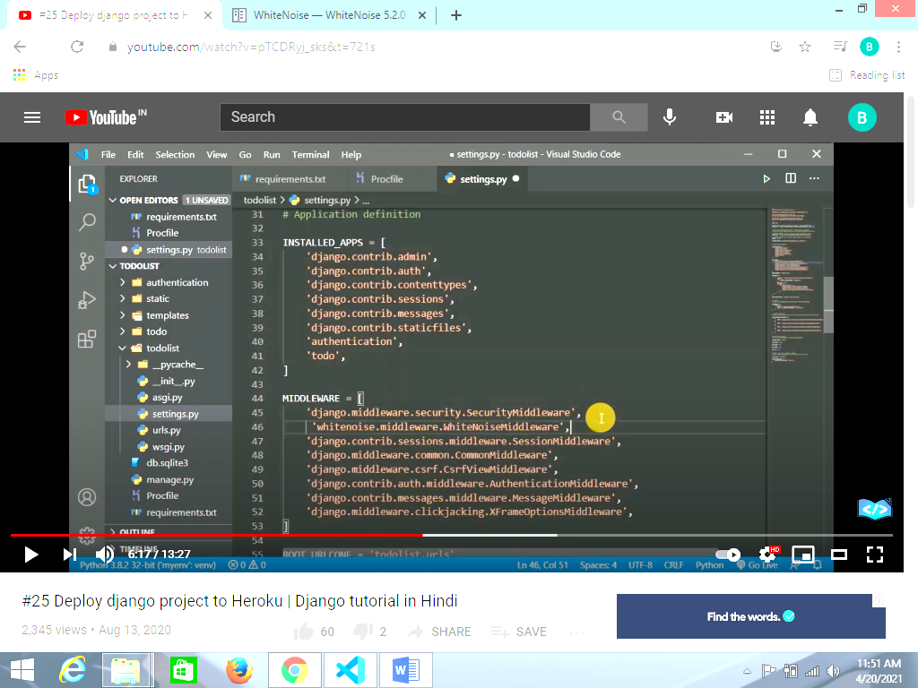

1. Do the setting for static as per django guideline STATIC_ROOT = "/var/www/example.com/static/"

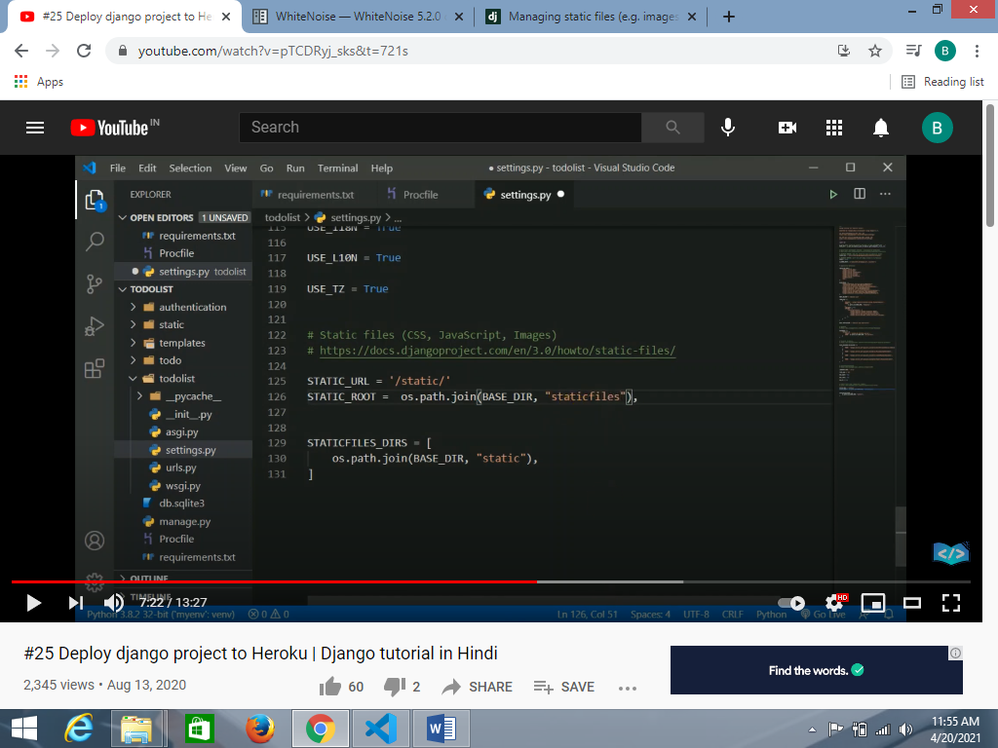

**All settings done now start Deployment**

1. Run command *heroku login*
2. After than open this browser



1. Then click on deploy

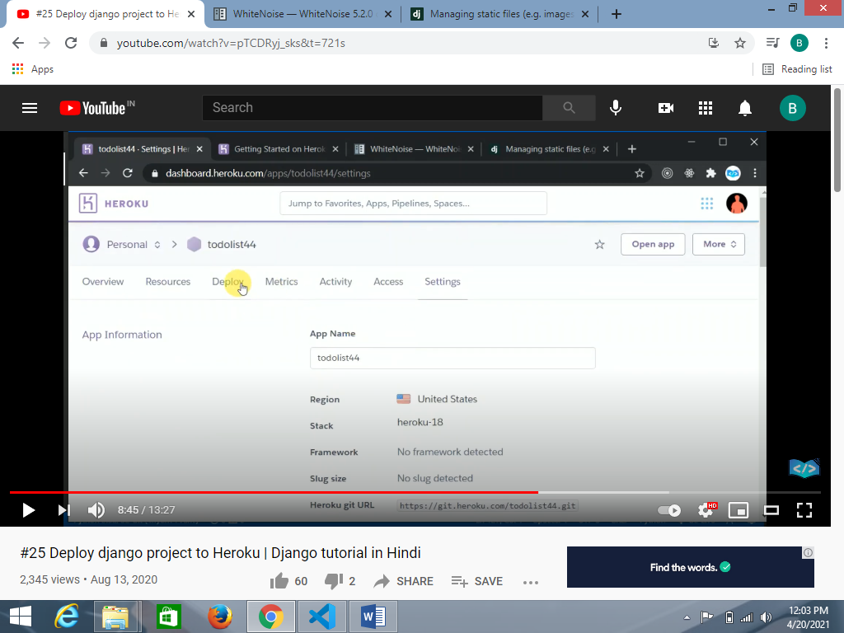

1. Login Heroku account & run following command.
2. git init
3. heroku git:remote –a webmycollection

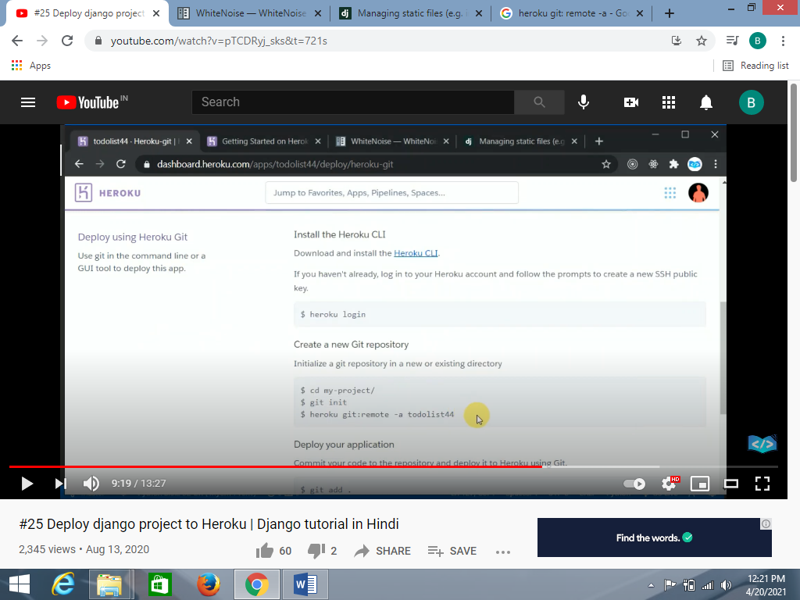

1. git add .

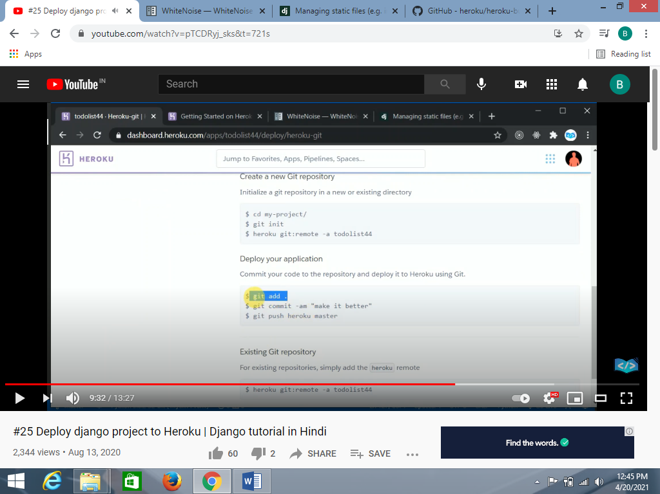

1. git commit –am……….
2. git push heroku master

Finally deployed & get urls and visit on the same